PUF-IRS crosswalk for diagnostics and targeting
Updated: 12/6/2025

Introduction
This document describes the correspondence between important PUF 2015 variables and IRS spreadsheets that report aggregate values - in other words, it tells us, for a given PUF 2015 variable, such as one representing net capital gains, what IRS spreadsheet and cell contains IRS’s published sum for that tax return item. Understanding this correspondence is important because (1) it can help diagnose how well the 2015 PUF, when extrapolated and reweighted for future years, corresponds to IRS-reported values for those years, both in aggregate and by subcategories such as AGI ranges and marital statuses, and (2) it can help establish targets for file reweighting and extrapolation.

This document is intended to provide enough information about data sources and definitions for others to verify or reproduce the PUF-IRS correspondence, and to extend it to other variables as needed.

The primary result is this PUF-IRS crosswalk table.

The sections below:
- give selected links
- provide the resulting crosswalk table
- explain the data and methods using examples
- discuss issues and concerns
- provide additional details for selected variables

Links
- Google Drive documentation folder, with subfolders for
  - Relevant IRS spreadsheets and Publication 1304
  - Relevant IRS forms and instructions
  - PUF 2015 documentation, including the:
    - Main file
    - Demographics file
- IRS web pages (key documents are also in the Google Drive folder)
  - Publication 1304 all years landing page and 2021 pdf
  - Main SOI tables -- selected important tables:
    - Table 1.1 All Returns: Selected Income and Tax Items, Size and Accumulated Size of Adjusted Gross Income (yyin11si.xls): 2021 (21in11si.xls)
    - Table 1.2 All Returns: Adjusted Gross Income, Exemptions, Deductions, and Tax Items, Size of Adjusted Gross Income and Marital Status (yyin12ms.xls): 2021 (21in12ms.xls)
    - Table 1.4 All Returns: Sources of Income, Adjustments Deductions and Exemptions, and Tax Items, Size of Adjusted Gross Income (yyin14ar.xls): 2021 (21in14ar.xls)
  - IRS prior years search tool
- Selected repos and dashboards:
  - policyengine-us
  - Tax-Calculator
  - taxdata
  - tax-microdata-benchmarking
  - tmd-dashboard
  - tmd-dashboard streamlit app
  - taxdata-psl (Boyd)
  - HTML table of potential targets (Boyd)

Issues
- Aggregate records

PUF-IRS crosswalk table for tax-return filers
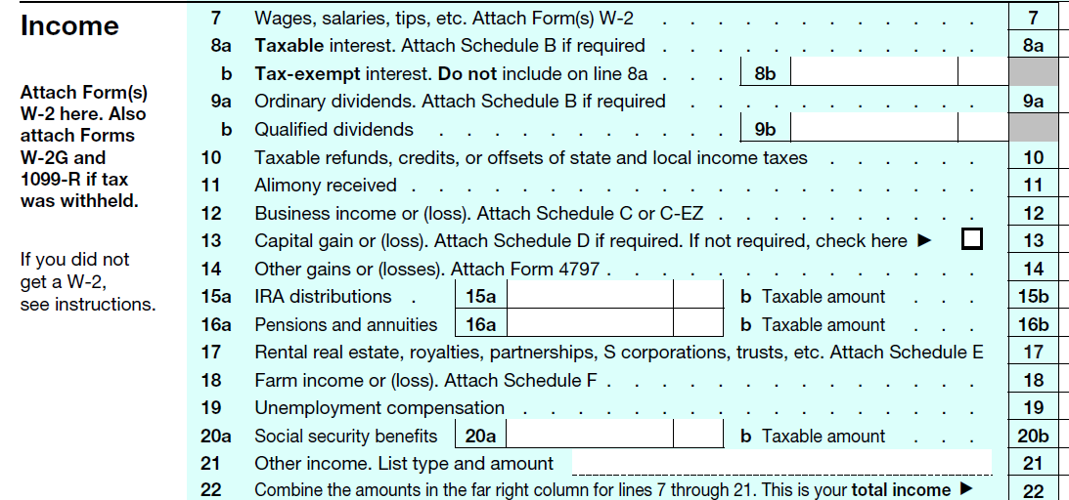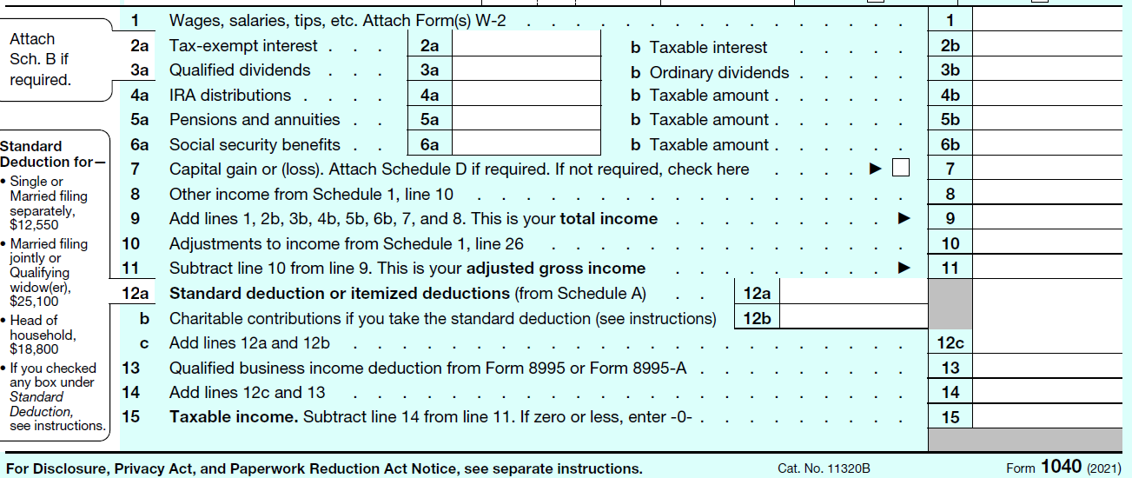

Concept | PUF 2015 correspondence  to 2015 & 2021 IRS reports & forms:  PUF variable  IRS location or calculation  IRS Form 1040 or schedule | IRS totals ($b) | Notes and issues
AGI components
Salaries & wages | e00200  15in14ar.xls_G9  21in14ar.xls_G9  2015: 1040 Line 7  2021: 1040 Line 1 | 2015: $7,112.2  2021: $9,022.4 | Both PUF and IRS are AFTER contributions to retirement plans  1040 amount is from W-2 box 1, which is after retirement contributions
Capital gains, excluding CG distributions | e01000  15in14ar.xls_(AA9 - AC9)  21in14ar.xls_(AA9 - AC9)  2015: 1040 Line 13 excl CG dist  2021: 1040 Line 13 excl CG dist | 2015: $694.952 = 713.598 - 18.646  2021: $2,032.553 = 2,048.795 - 16.242 | e01000 = positive net gains minus negative  $86.7 billion of positive net gains (12.5% of all net gains) is on the aggregate records in 2015  Target net gains and net losses separately
Capital gains distributions | e01100  15in14ar.xls_Y9  21in14ar.xls_Y9  2015: 1040 line 13 if CG dist  2021: 1040 line 13 if CG dist | 2015: $11.563  2021: $23.890
Taxable interest | e00300  15in14ar.xls_I9  21in14ar.xls_I9  2015: 1040 line 8a  2021: 1040 line 2b | 2015: $95.881  2021: $103.535
Tax-exempt interest | e00400  15in14ar.xls_K9  21in14ar.xls_K9  2015: 1040 line 8b  2021: 1040 line 2a | 2015: $61.871  2021: $55.518
Ordinary dividends | e00600  15in14ar.xls_M9  21in14ar.xls_M9  2015: 1040 line 9a  2021: 1040 line 3b | 2015: $260.253  2021: $386.961
Qualified dividends | e00650  15in14ar.xls_O9  21in14ar.xls_O9  2015: 1040 line 9b  2021: 1040 line 3a | 2015: $203.188  2021: $295.906
Business or profession income | e00900  15in14ar.xls_(U9 - W9)  21in14ar.xls_(U9 - W9)  2015: 1040 line 12  2021: ?? | 2015: $331.814 = 391.976 - 60.161  2021: $411.502 = 517.082 - 105.580 | e00900 = positive bus/prof income minus negative  Target positive and negative separately  Figure out where it is on 2021 forms  QBID deduction is on the 1040 in 2021
Qualified business income deduction | ??<variable name>  2015: n/a  21in14ar.xls_Y9  2021: 1040 line 13 | 2015: n/a  2021: $205.780 | Calculated; not in PUF 2015.  Qualified business income deduction from Form 8995 or Form 8995-A
Taxable IRA  distributions | e01400  15in14ar.xls_AI9  21in14ar.xls_AI9  2015: 1040 line 15b  2021: 1040 line 4b, 1040A | 2015: $253.213  2021: $408.382
Total pensions and annuities received | e01500  15in14ar.xls_AK9  21in14ar.xls_AK9  2015: 1040 line 16a  2021: 1040 line 5a | 2015: $1,169.067  2021: $1,506.948
Pensions and annuities included in AGI | e01700  15in14ar.xls_AM9  21in14ar.xls_AM9  2015: 1040 line 16b  2021: 1040 line 5b | 2015: $689.992  2021: $858.038
Combined partnership and S corporation net income/loss (+/-) | e26270  15in14ar.xls_(BE9 - BG9)  21in14ar.xls_(BE9 - BG9 +  BI9 - BK9)  2015: Schedule E line 32  2021: ?? | 2015: $629.004 = 755.623 - 126.618  2021: $975.656 =  (469.816 - 168.152 +  766.681 - 92.689) | Determine IRS lines in 2021  2015: partnership & S corp reported combined in IRS spreadsheets  2021: partnership & S corp reported separately  2021 calculation is inferred - IRS  more-detailed variables appear to be available  Target positive and negative (P+S) separately
Unemployment compensation in AGI | e02300  15in14ar.xls_BQ9  21in14ar.xls_BU9  2015: 1040 line 19  2021: ?? | 2015: $27.225  2021: $208.872 | Determine IRS lines in 2021, check Schedule 1
Gross Social Security benefits | e02400  15in14ar.xls_BS9  21in14ar.xls_BW9  2015: 1040 line 20a  2021: 1040 line 6a | 2015: $605.152  2021: $791.161
Social Security benefits in AGI | e02500  15in14ar.xls_BU9  21in14ar.xls_BY9  2015: 1040 line 20b  2021: 1040 line 6b | 2015: $277.411  2021: $412.830
Itemized deductions
Medical and dental expenses subject to reduction by AGI limit | e17500  15in21id.xls_BN10  21in21id.xls_BL10  2015: Schedule A, line 1  2021: ?? | 2015: $133.785  2021: $101.861 | PUF documentation says $13.379, presumably erroneously.  Note that title is “subject to reduction”, not “after reduction”. Seems consistent with form and spreadsheet number.
State and local taxes (income or general sales tax) | e18400  15in21id.xls_BT10  21in21id.xls_BT9  2015: Schedule A, line 5  2021: | 2015: $352.701  2021: $258.640 | PUF documentation says $35.270, IRS spreadsheet says $352.701; presumably mistake in documentation  11.25 of 35.27 (31.9%) is on aggregate records??? is 11.25 wrong, also?
Real estate tax deductions | e18500  15in21id.xls_BZ10  21in21id.xls_BZ9  2015: Schedule A, line 6  2021: | 2015: $188.606  2021: $99.984 | PUF documentation says $18.860, IRS spreadsheet says 188.606
Total interest paid deduction | e19200  15in21id.xls_CF10  21in21id.xls_CH10  2015: Schedule A, line 15  2021: | 2015: $304.461  2021: $163.274 | PUF documentation says 30.446, presumably erroneously
Cash contributions | e19800  15in21id.xls_CV10  21in21id.xls_CZ10  2015:  2021: | 2015: $162.567  2021: $162.797 | PUF documentation says 16.257, presumably erroneously
Other than cash contributions | e20100  15in21id.xls_CX10  21in21id.xls_DB10  2015:  2021: | 2015: $70.870  2021: $121.375 | Same as PUF documentation
Tax credits
Tax items
Adjusted gross income | e00100  15in14ar.xls_C9  21in14ar.xls_C9 | 2015: $10,210.310  2021: $14,795.614
Taxable income | e04800  15in14ar.xls_EC9  21in14ar.xls_EC9 | 2015: $7,350.295  2021: $11,767.185

Method for producing the PUF-IRS crosswalk table, and how to interpret it
The PUF-IRS crosswalk table shows, for each of several tax-related concepts:
- the 2015 PUF variable name
- for both 2015 and 2021:
  - the location of a published counterpart in an IRS spreadsheet or any calculations needed to produce the counterpart
  - the location on tax forms
  - IRS totals for the variable
- relevant notes or known issues.

Not all elements of the table are completed yet. Note that some IRS variables can be found in multiple spreadsheets but the crosswalk table only gives the name of the spreadsheet this project uses.

An example
The screenshot below shows the table row for salaries and wages.
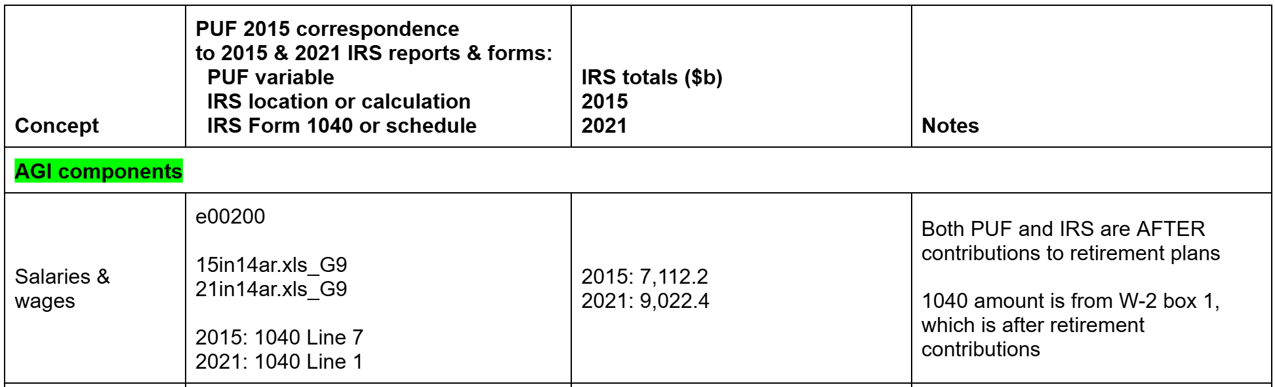

The “PUF 2015 correspondence” column shows three blocks of information:
- e00200, the PUF variable name for salaries and wages
- The IRS filenames and cell address for the published data corresponding to e00200 in 2015 and 2021:
  - The 2015 file is 15in14ar.xls is the name of the main IRS file we use for wages in 2015. It follows a standard IRS naming convention: 15=2015, in=individual income tax, 14=IRS Table 1.4, ar=All returns.
  - The 2021 file is 21in14ar.xls. Per the links above, the files can be found from the main IRS landing page for tables, or in a project Google Drive folder (helpful in case the IRS changes file locations).
  - In each year, total salaries and wages were in cell G9.

The “IRS totals” column shows total salaries and wages reported by the IRS in 2015 and 2019 -- the amounts in cell G9 of the file for each year, as shown below:

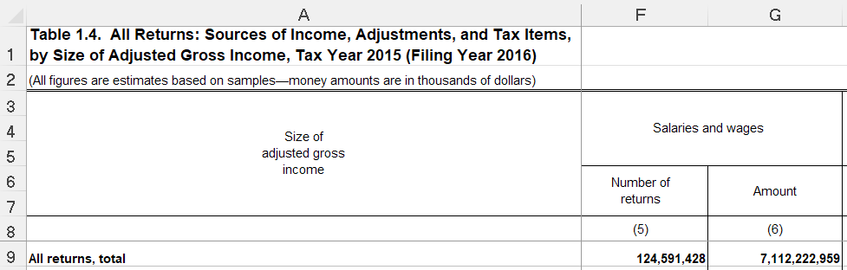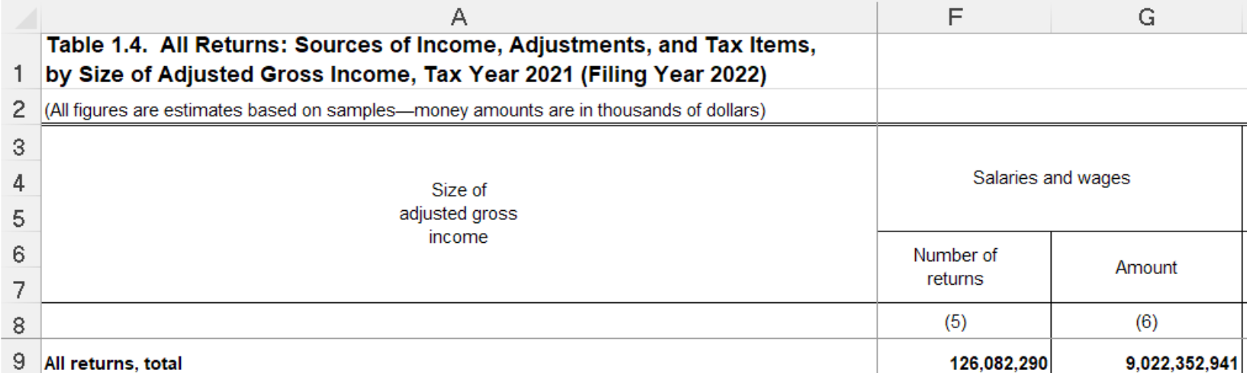

The screenshot below shows that cell G9 in 2021 contains $9,022.353 billion. Note also that rows below row 9 contain a breakdown by AGI range, and the column to the left contains the number of tax filers who had nonzero wages in 2021. This is the usual layout of IRS tables for most variables, although there are exceptions. Thus, if targeting or examining not just the amount of total wages, but numbers of returns with wages, and values by AGI range, we would examine rows below row G, and the column to the left (F).

How do we know cell G9 in 2015 and corresponds to 2015 PUF variable e00200 and IRS Form 1040 line 1?
To determine correspondence, first we examine IRS reports for 2015 and compare them to PUF information for 2015. Then, where possible we confirm that definitions are the same for 2021 as for 2015. Finally, adjust as needed.

2015 correspondence between PUF and IRS reports
We determine 2015 correspondence by comparing values from the Full SOI Individual Sample as reported in 2015 PUF documentation with IRS-published values reported in an IRS spreadsheet for 2015. We also compare PUF definitions to definitions used for IRS reporting.

Comparing values
The 2015 PUF documentation contains a table starting on page 46 that gives for each variable the amount in the 2015 Full SOI individual Sample (which we do not have access to) -- the data that IRS uses for published totals. The screenshot below, from the PUF documentation table, shows that total wages in 2015 from the IRS Full SOI sample were $7.112 trillion. (The table also shows the amount in the 2015 Public Use Sample, available to us, is $7.156 trillion, quite close to the full sample. In theory, we can reproduce this number by summarizing the full PUF. CAUTION: The page 46 table gives the total PUF amount, including the values on the four aggregate records, which, at present, we are not using in our PolicyEngine-PUF data file.)

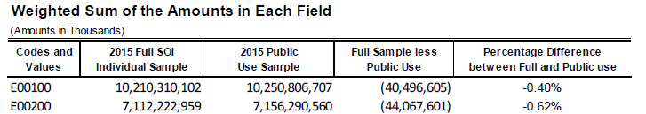

Next we examine the IRS-reported total for 2015, in IRS Table 1.4 for 2015 (15in14ar.xls), which coincidentally is in cell G9, the same location as in 2021 (this will not always be the case ). The numbers match -- reported total salaries and wages also are $7.112 trillion:

Comparing definitions
In some cases, we also compare definitions. The 2015 PUF documentation, on p.6, defines e00200 as “Salaries and wages,” and page A-2 shows that e00200 comes from line 7 of 2015 Form 1040:

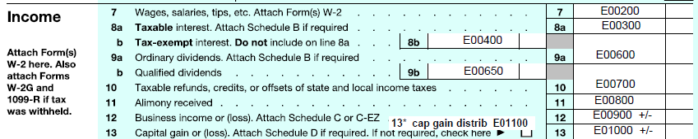

Publication 1304 for 2015, Individual Income Tax Returns Complete Report: 2015, p.196 says that what IRS tables refer to as Salaries and Wages also come from line 7, Form 1040:
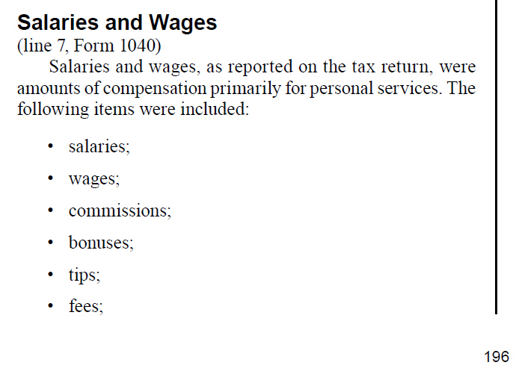

2015 Conclusion
At this point, we have pretty good evidence that PUF e00200 corresponds to IRS Salaries and Wages in 2015, and is reported on line 7 of 2015 Form 1040.

2021
In 2021 we don’t have any new PUF values. However, we have to see whether IRS reporting definitions have changed, or values have changed in unbelievable ways.

First, we look at the definition of Salaries and Wages, found on p.328 of Publication 1304 for 2021; an excerpt from 2021 Form 1040 is to the right. The definition looks to be essentially the same, but now the data are reported on Form 1040 line 1 instead of line 7:
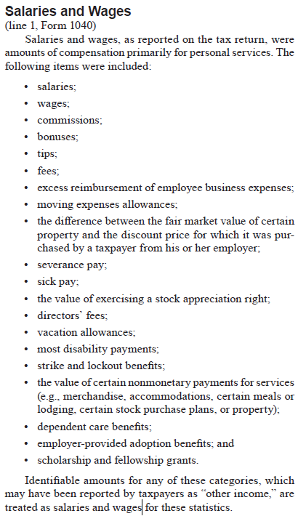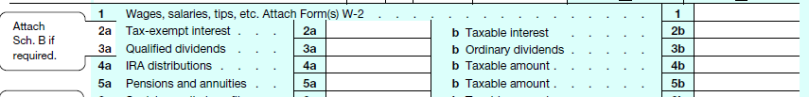

Next, we look for an unbroken time series of salaries and wages. We find this by piecing together a time series from Publications 1304 for 2019 and 2021, being sure to look at current dollars in all cases. Here is the time series found in Table A in 2019 - it starts with the familiar $7.112 trillion in 2015, increases to $7.578 trillion in 2017, and ends with $8.273 trillion in 2019:
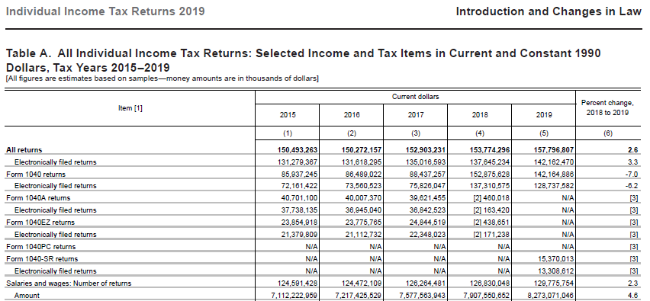

We follow that with the comparable time series from the 2021 Publication 1304: We see $7.578 trillion for 2017 and end with $9.022 trillion in 2021. So we want to find $9.022 trillion in relevant IRS spreadsheets.
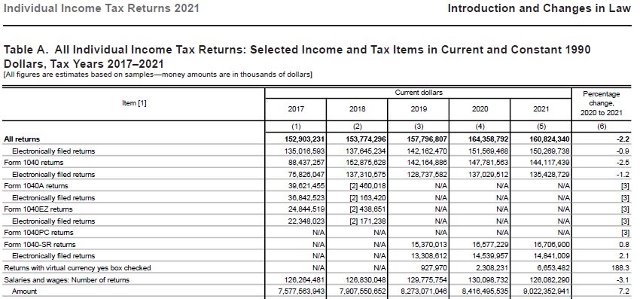

Finally, we look at the relevant IRS spreadsheet and see the familiar $9.022 trillion in cell G9:

Taken together, this is pretty good evidence that IRS Table 1.4 in 2021 (21in14ar.xls) cell G9 is our 2021 counterpart to the PUF 2015 variable e00200.

IRS Aggregate records
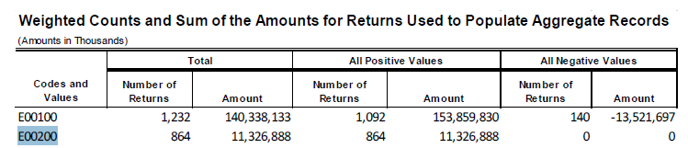
Average $13.1 million per return.
11,326,888 / 7,156,290,560 = 0.16%

Issues
- Adding things
- Aggregate records
- Following up on issues
- Some things we can’t check

Specific variables

Salaries and wages
The key issue is whether salaries and wages are before or after subtracting contributions to retirement plans:
- PUF variable e00200 is from Form 1040 Line 7, which is generally from W-2 box 1, which is AFTER subtracting retirement contributions.
- IRS data for 2021 Table 1.4 are from Form 1040 Line 1, which is the counterpart to 2015’s line 1.
Thus, both PUF and IRS are AFTER subtracting contributions to retirement plans.

Form 1040 line 7. Main 2015 instructions say, “Enter the total of your wages, salaries,
tips, etc. If a joint return, also include your spouse's income. For most people, the amount to enter on this line should be shown in box 1 of their Form(s) W-2.” Employer instructions say, “do not include elective deferrals (such as employee contributions to a section 401(k) or 403(b) plan) except section 501(c) (18) contributions.”
Note that W-2 box 1 is AFTER subtracting contributions to retirement plans.

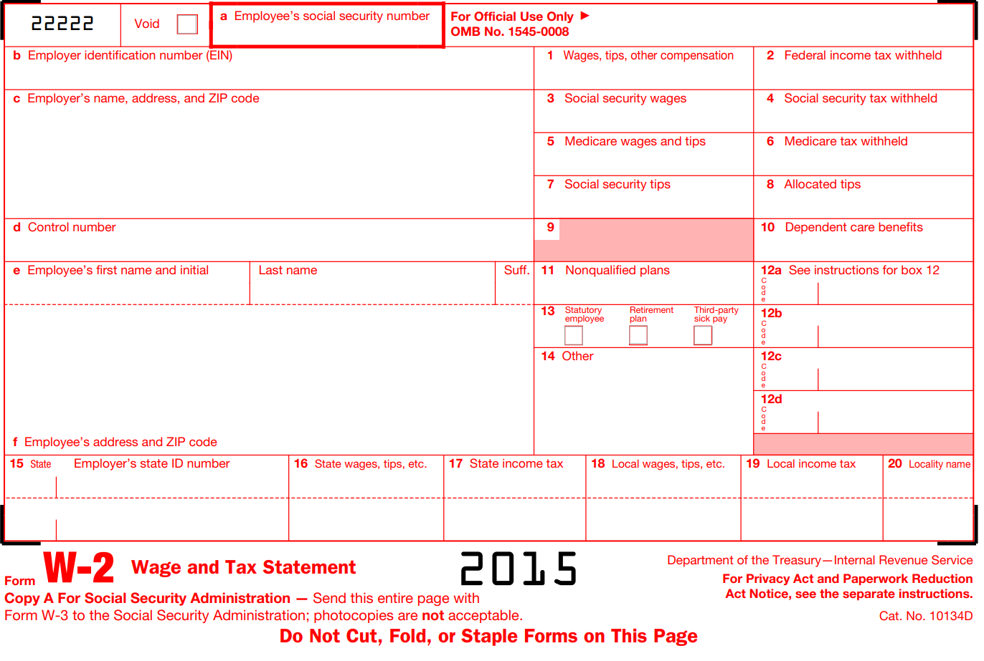

Capital gains

PUF
- e01000 is called “Net capital gain or loss (+/-)”. e01000 is included on Form 1040 Line 13, and appears to be pulled from Schedule D. (See 1040 excerpt)
- e01100 is “Capital gain distributions reported on Form 1040”. For 1040A filers it is separately reported on line 10; for 1040 filers, it is included in line 13. (See 1040A excerpt; PUF documentation excerpt)
- Per documentation, weighted sum in PUF of e01000 in 2015 was $701.379 billion and weighted sum of e01100 was $11.767 billion. Combined sum of e01000 and e01100 in 2015 was $713.146 billion. It is possible to calculate from the PUF the sums of positive and negative amounts for each, as well as numbers of filers with positive and negative amounts. (PUF documentation excerpt)

IRS
- Table 1.4 reports capital gain distributions reported on Form 1040. 2015 total of $11.563 billion is the same as the full SOI sample, and is close to $11.767 billion PUF e01100.
- Taxable net gains on Table 1.4 were $713.598 billion and taxable net losses were $18.646 billion. The net of these two was $694.952 billion (713.598 - 18.646). This is the same as the full SOI sample and is close to the PUF sum of $701.379 billion (PUF sum is 0.9% higher).
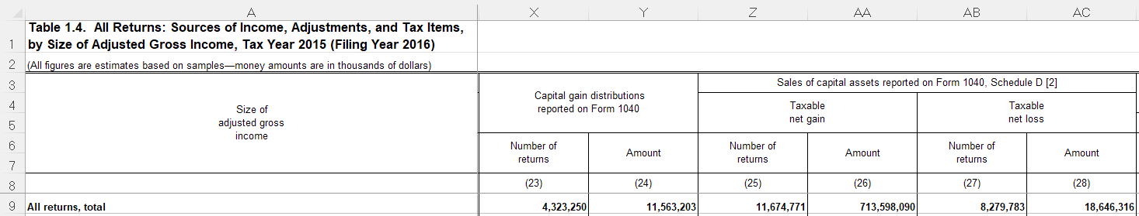

Backup

1040 excerpt

1040A excerpt
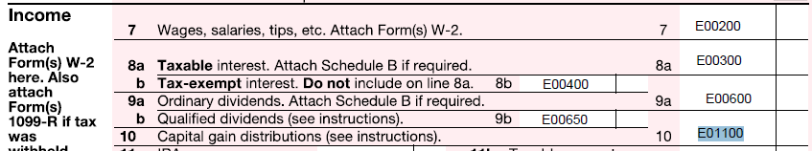

PUF documentation excerpt

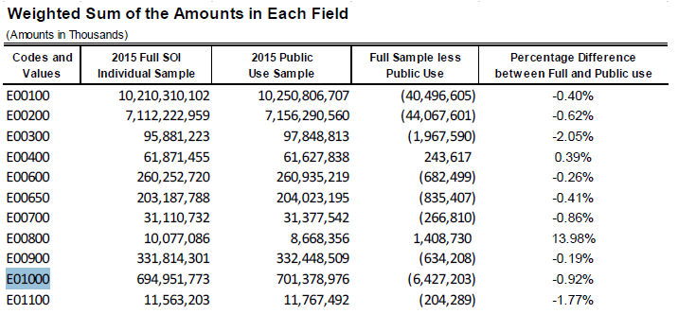

15in14ar.xls excerpt (Table 1.4 2015)

PUF

IRS
cggross Table 1.4 2015 and 2021 AA9, loss AC
puf taxable c01000

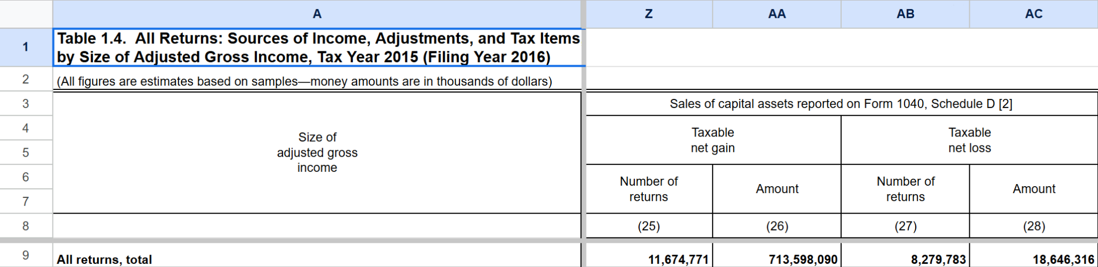

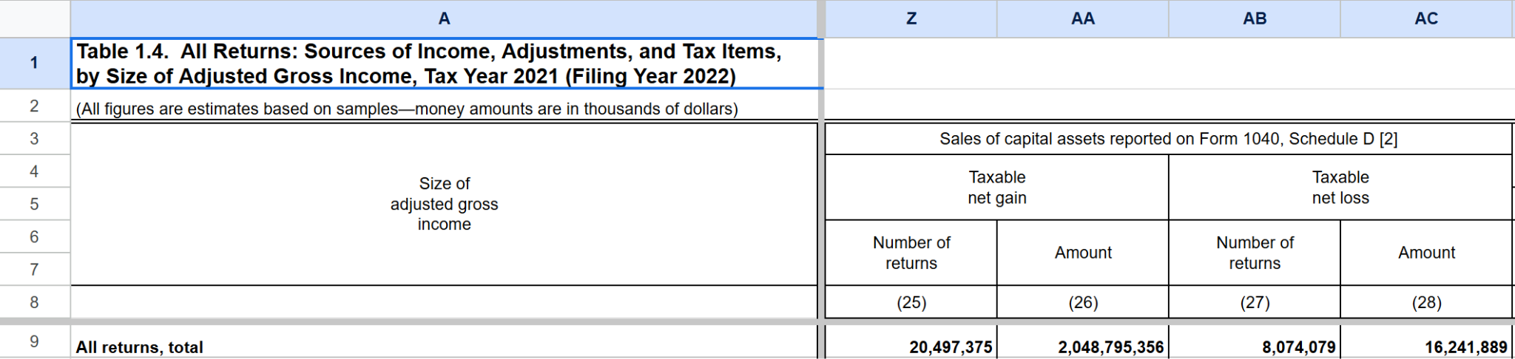

Net Long-Term Gain or Loss from Sales of Capital Assets
2015:
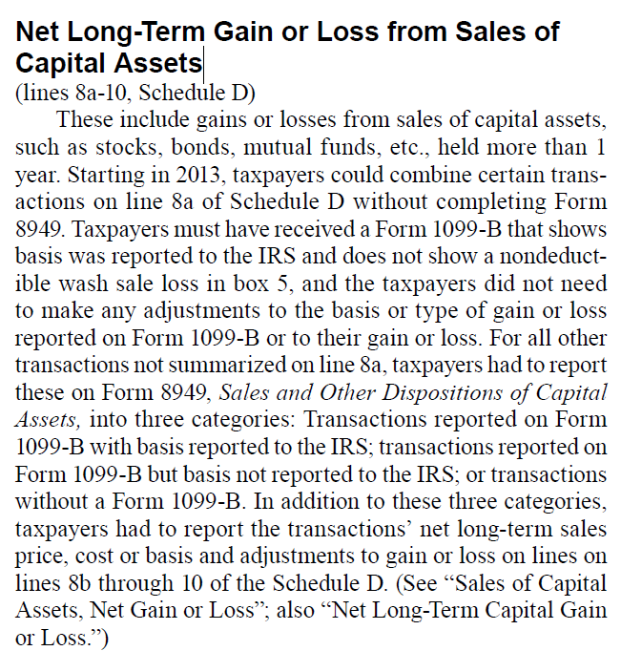

Sales of Capital Assets, Net Gain or Loss
2015
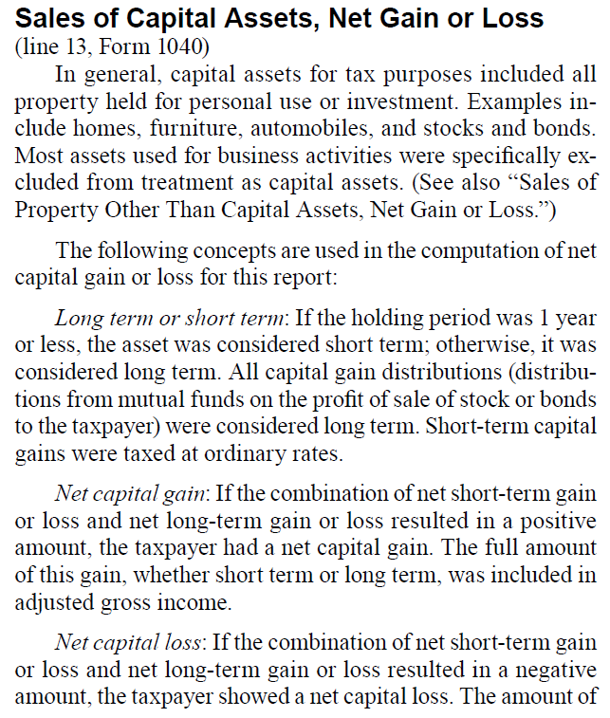
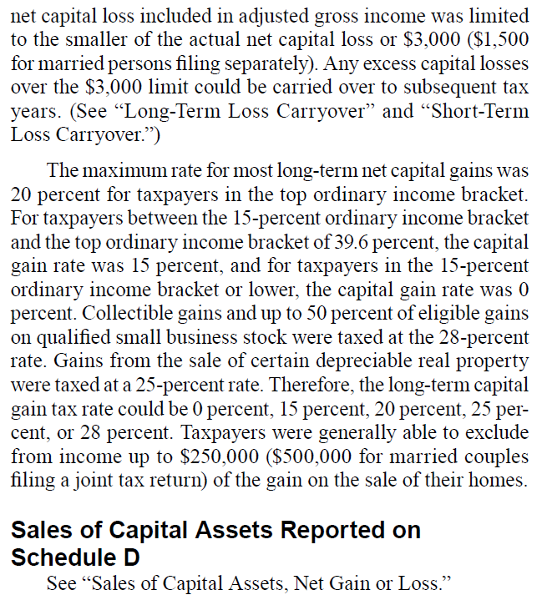

Total income tax

IRS
IRS spreadsheets define taxable returns based on what they call “Total income tax”. Here is the 2020 definition of total income tax, from the 2020 Publication 1304 (p.24), emphasis added:
Total income tax, as presented in these statistics, is the sum of income tax after credits (including the subtraction of refundable credits such as the EIC, American opportunity credit, net premium tax credit, and regulated investment company credit) plus the net investment income tax and tax on accumulation distribution of trusts from Form 4970 and is limited to zero (it cannot be negative). This calculation does not account for the impact of refundable credits, which have the potential effect of creating a negative tax liability for some taxpayers. This was accounted for by subtracting the portion of refundable credits that offset all other taxes and the refundable portion of credits from total income tax. Total income tax minus refundable credits increased 7.2 percent to $1.6 trillion for 2020 (Figure E).

IRS defines total income tax more formally in the glossary on p.321. They say clearly here that total income tax is what they use to define taxable returns:
(line 24, Form 1040—any excess advance premium tax credit (APTC) repayment on line 2, Schedule 2, + any Net Investment Income Tax on line 8b, Schedule 2, + any Form 4970 tax on line 8c, Schedule 2 - line 27, Form 1040 - line 28, Form 1040 - line 29, Form 1040 - line 12a, Schedule 3 - line 12c, Schedule 3 - portion on line 12d, Schedule 3, related to tax on repatriated income, limited to zero.) “Total income tax” was the sum of income tax after credits (including the subtraction of the excess APTC repayment, earned income credit, additional child tax credit, American opportunity credit, regulated investment company credit, health coverage credit, recovery rebate credit, and qualified sick and family leave credit) less any deferred tax on repatriated (965) income plus the Net Investment Income Tax from Form 8960 and the tax from Form 4970. It did not include any of the other taxes that made up total tax liability. Total income tax was the basis for classifying returns as taxable or nontaxable.

PUF

Taxable interest

PUF
E00300 Interest received
1040 line 8a
1040A line 8a
1040EZ line 8a
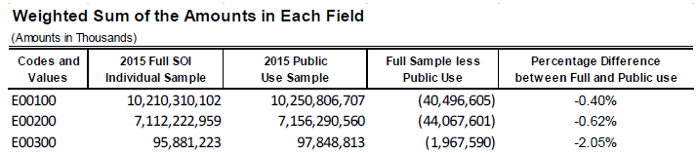
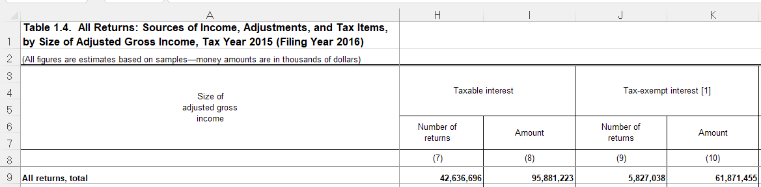

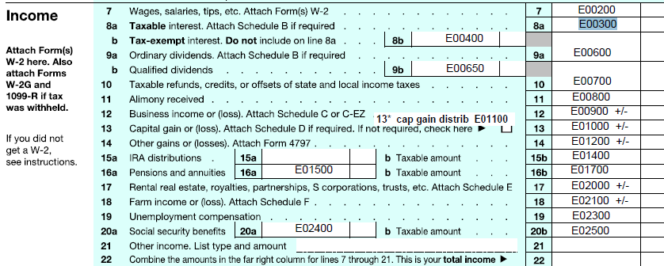

IRS

Tax-exempt interest
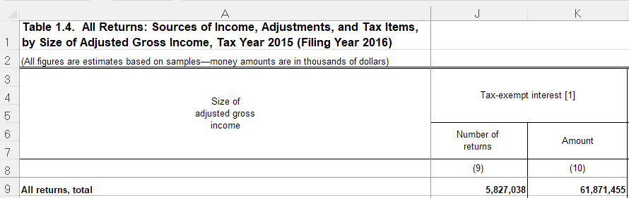
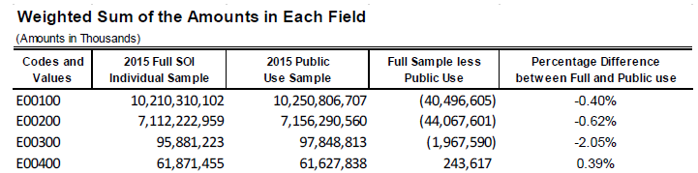

PUF

IRS

Ordinary dividends

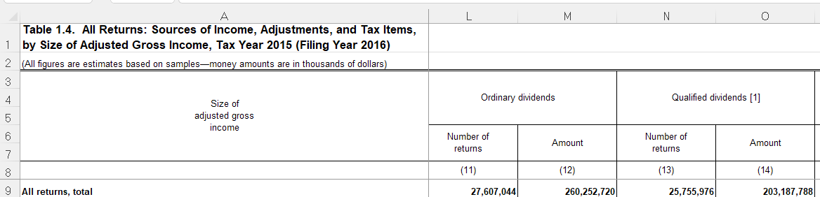

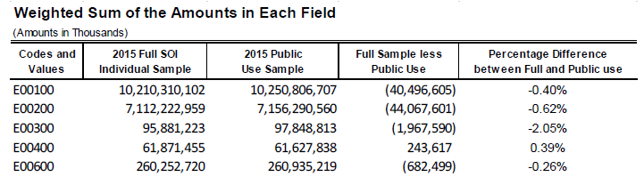

Qualified dividends
e00650

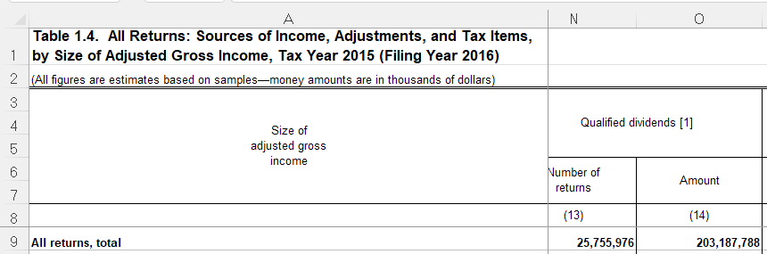

PUF weighted sums
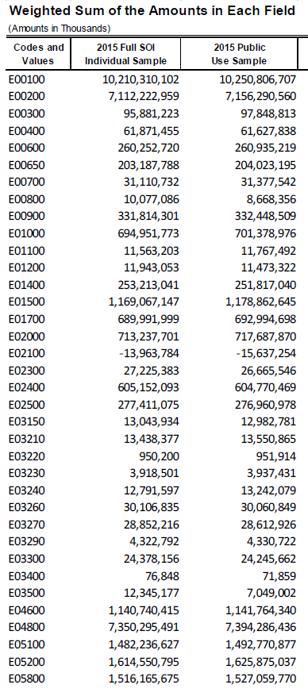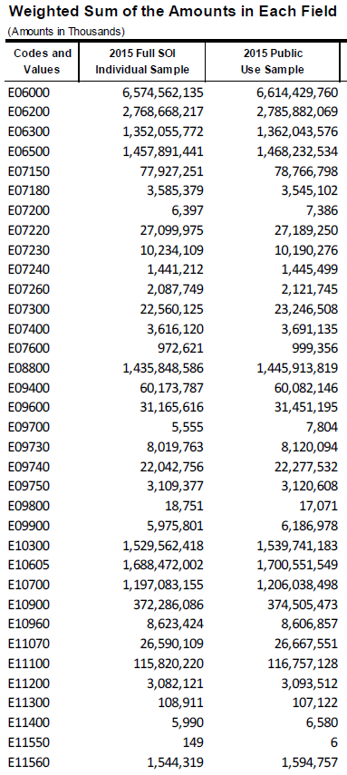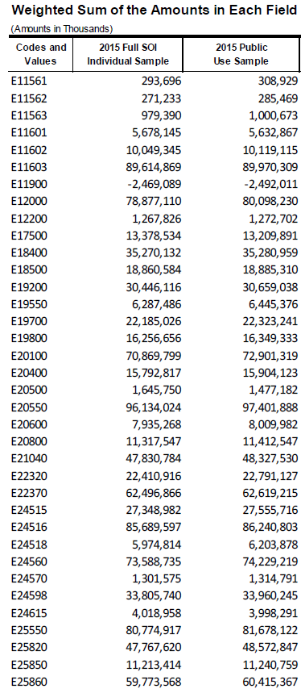

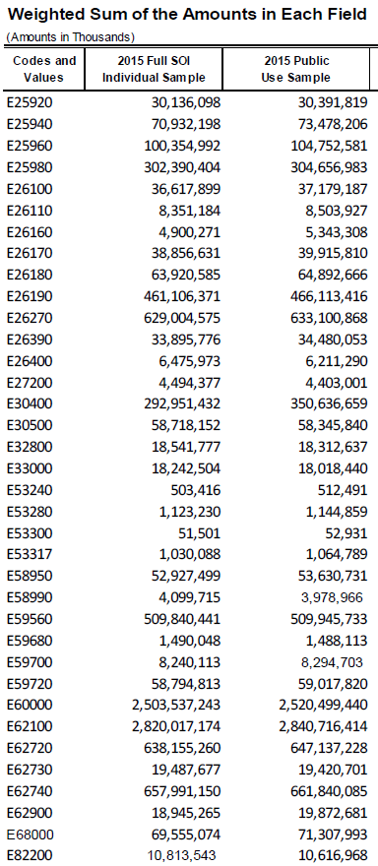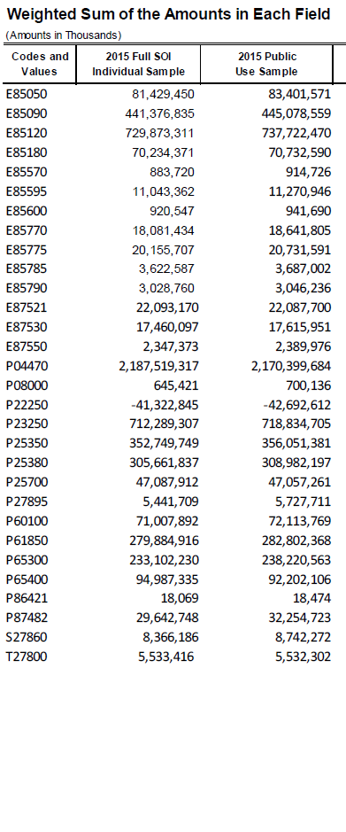

PUF Aggregate records
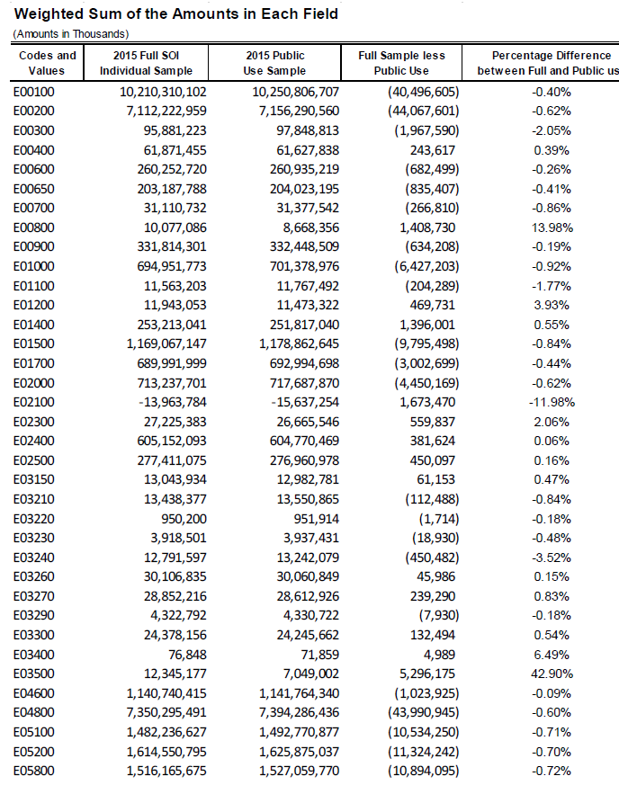

IRS Table 1.4
